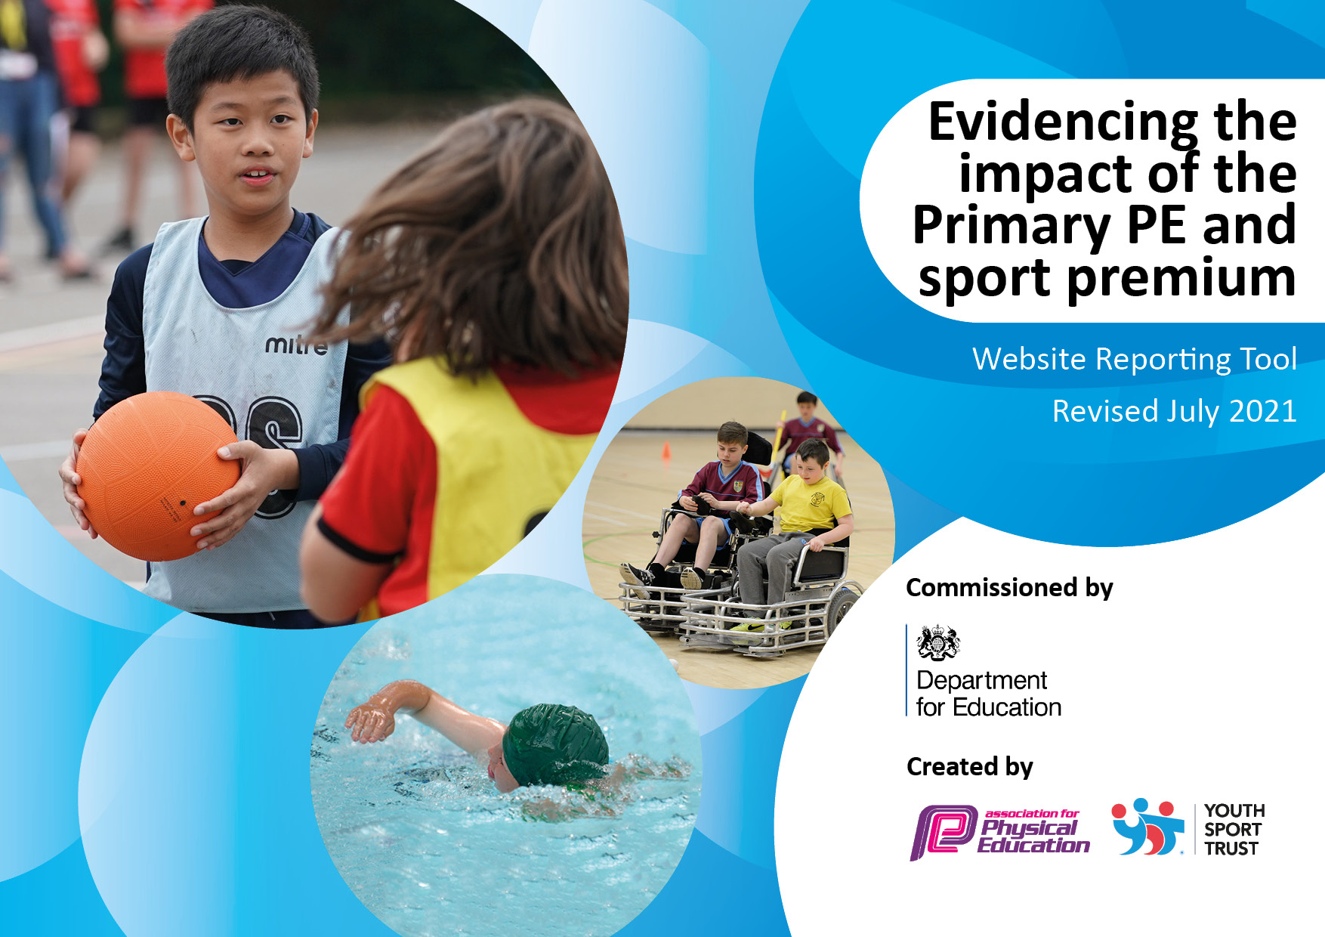
July 2022 Update
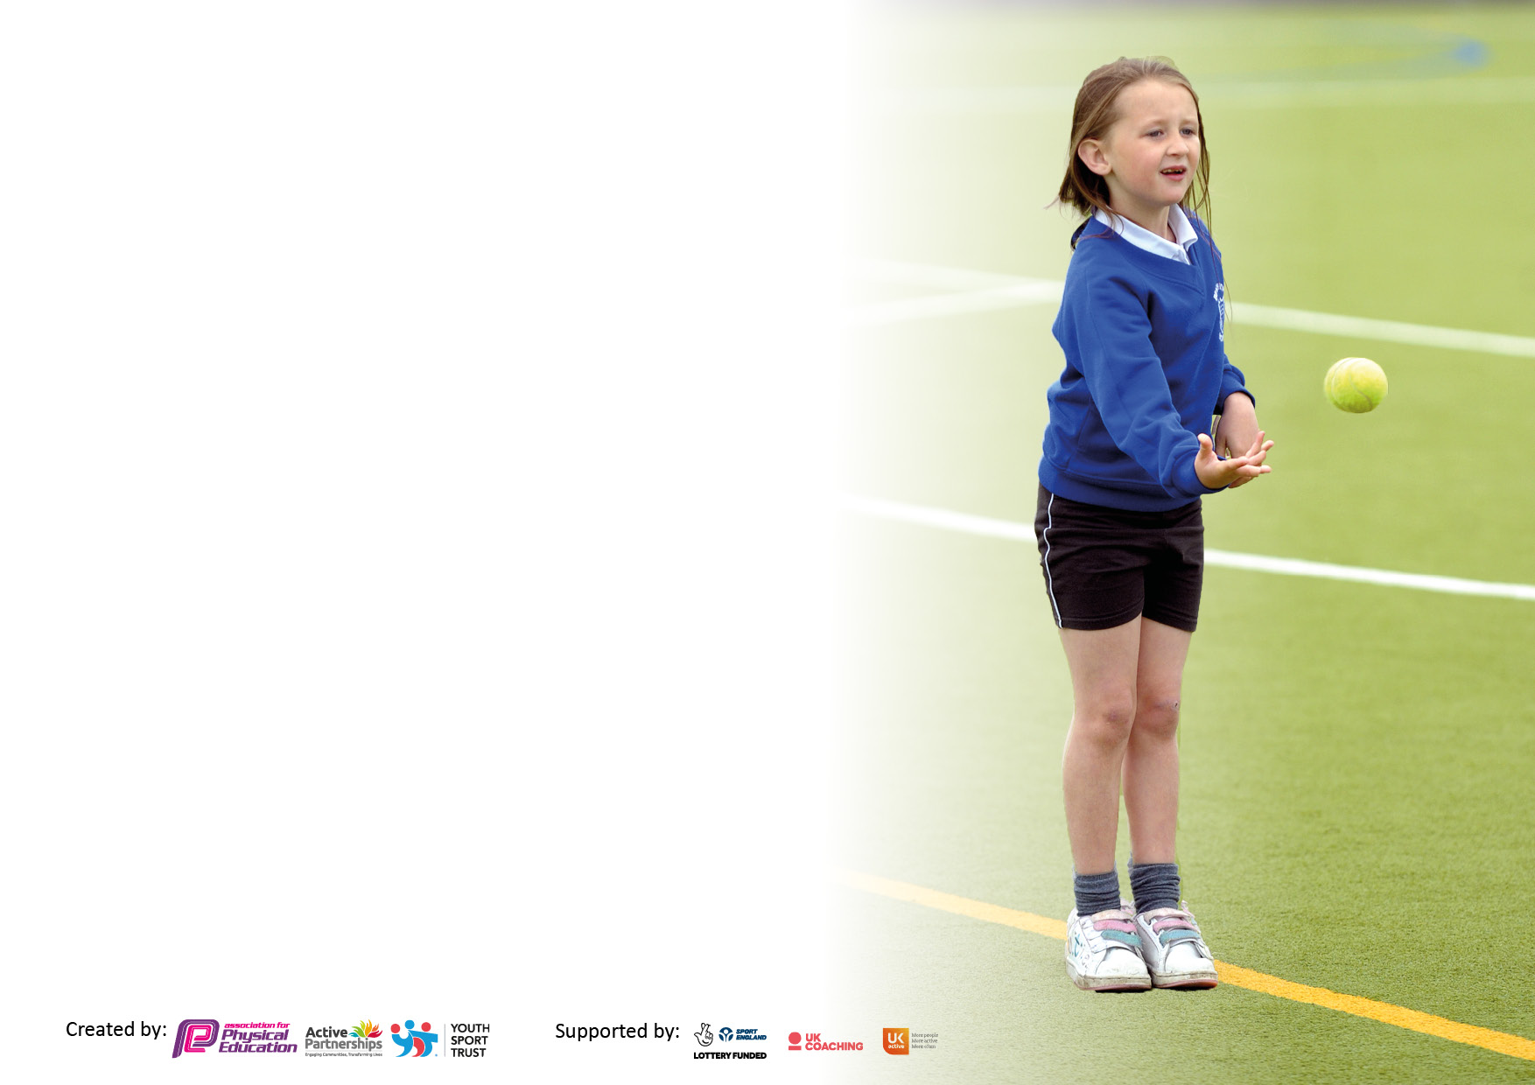

It is important that your grant is used effectively and based on school need. The Education Inspection Framework makes clear there will be a focus on ‘whether leaders and those responsible for governors all understand their respective roles and perform these in a way that enhances the effectiveness of the school’.

Under the Quality of Education Ofsted inspectors consider:
Intent - Curriculum design, coverage and appropriateness
Implementation - Curriculum delivery, Teaching (pedagogy) and Assessment
Impact - Attainment and progress

To assist schools with common transferable language this template has been developed to utilise the same three headings which should make your plans easily transferable between working documents.

Schools must use the funding to make additional and sustainable improvements to the quality of Physical Education, School Sport and Physical Activity (PESSPA) they offer. This means that you should use the Primary PE and sport premium to:

- Develop or add to the PESSPA activities that your school already offer
- Build capacity and capability within the school to ensure that improvements made now will benefit pupils joining the school in future years
- The Primary PE and sport premium should not be used to fund capital spend projects; the school’s budget should fund these.

Pleasevisitgov.ukfortherevisedDfEguidanceincludingthe5keyindicatorsacrosswhichschoolsshoulddemonstrate animprovement.Thisdocumentwillhelpyoutoreviewyourprovisionandtoreportyourspend.DfEencouragesschools to use this template as an effective way of meeting the reporting requirements of the Primary PE and sport premium.

We recommend you start by reflecting on the impact of current provision and reviewing the previous spend.

Schools are required to publish details of how they spend this funding, including any under-spend from 2019/2020, as well as on the impact it has on pupils’ PE and sport participation and attainment. All funding must be spent by 31st July 2022.

We recommend regularly updating the table and publishing it on your website throughout the year. This evidences your ongoing self-evaluation of how you are using the funding to secure maximum, sustainable impact. Final copy must be posted on your website by the end of the academic year and no later than the 31st July 2022. To see an example of how to complete the table please click HERE.

Details with regard to funding
Please complete the table below.

Total amount carried over from 2019/20 | £13271
Total amount allocated for 2020/21 | £18860
How much (if any) do you intend to carry over from this total fund into 2021/22? | £3421
Total amount allocated for 2021/22 | £18860
Total amount of funding for 2021/22. To be spent and reported on by 31st July 2022. | £22281

Support for review and reflection - considering the 5 key indicators from DfE, what development needs are a priority for your setting and your students now and why? Use the space below to reflect on previous spend, identify current need and priorities for the future.

Key achievements to date: | Areas for further improvement and baseline evidence of need:
- Partnership with Pennine Sporting Alliance has been established.  - Sessions will be delivered by HTFC across three half terms (Autumn 1, Spring 1 & Summer 1) for children in KS1 and KS2.  - ‘Bikeability’ sessions booked for Autumn term.  - PE lead attended PSP introduction conference and has booked staff on CPD.  - Beyond the Physical PE Scheme introduced  - Bikeability training took place in the Autumn term. This has been booked again for next academic year.  - A link has been created with Hill View School. Regular Football competitions have taken place during Spring 2, Summer 1 and Summer 2. This will continue next academic year.  - HTFC coach has been working with staff in Y1,Y2,Y3 and Y4 in the Autumn, Spring and Summer terms to help deliver PE sessions and provide CPD.  - A team from Year 5 and 6 took part in the EFL Kids Cup organised by HTFC.  - Y4 children have taken part in the Primary Stars Football Competition.  - Dance coach has been running an after school club for Y4 ,5 and 6 in Spring 1.  - HTFC have led an after school football club every Friday (Autumn 2, Spring 1, Spring 2, Summer 1 and Summer 2)  - HTFC have led sessions in school every Tuesday all year. This has included working with Y5/6 on the Primary Stars Campaign.  - HTFC have also led sessions with Y3 children on the Planet Super League Campaign.  - Children in KS2 have taken part in promotional activities with HTFC.  - Pennine actions:  - Pennine staff have provided CPD to individual staff.  - A Pennine dance/yoga coach is delivering dance sessions and after school clubs during Spring 2 and Summer 2 to Year 3, 4, 5 and 6.  - Pennine coach Kat (school coordinator) delivered ‘Active Reading’ session for Year 1 and 2 in Autumn 1 and 2.  - Pennine coach Kat (school coordinator) undertook baseline PE data testing for Year 2, Year 4 and Year 6 in Autumn 1 and 2.  - Pennine coach Kat (school coordinator) delivered training to 20 Year 5 children to on play leading. We now have 20 qualified play leaders who will help deliver sessions at lunchtime and at sporting events.  - Play leaders delivered sessions to all KS1 children during Summer 2 with support from Pennine staff. (Summer 2)  - A group of children from Y 4,5 and 6 took part in Sports Hall Athletics (Spring 1)  - Y5 children took part in Pennine Cricket Competition and qualified for Kirklees finals. (Summer 1)  - Y5/6 children took part in Pennine Rounders competition (Summer 2)  - A group of 15 children from Year 4,5 and 6 performed at the Pennine Strictly Dance Festival at the Lawrence Batley Theatre on the 1st March (Spring 2).  - All Y4 children took part in National Sports Week and spent at day at Leeds Road Sports Complex – organised by Pennine.  - Three children from Y5/6 took part in the Pennine Sports Awards at the Town Hall and were awarded certificates for their contributions to school sport.  - All children in KS1/KS2 had Tennis coaching from Longley Tennis Club (Summer 2) | - To increase the skills and knowledge of staff in relation to teaching aspects of PE.  - To develop an appropriate system to monitor and assess the progress of pupils.  - To continue to raise the profile of PE.  - To continue to monitor the statutory 30 minutes of physical activity that needs to be provided by schools on a daily basis.  - To use the sports premium to improve the national curriculum requirements for swimming and water safety for year six pupils.  - To use the Pennine Sports Partnership effectively to assist with teaching of PE and attendance of competitive sporting events.  - To observe progress in key skills of Year 2, 4 and 6 children in their EOY baseline data tests carried out by PSP.

Swimming Data
Please report on your Swimming Data below.

Meeting national curriculum requirements for swimming and water safety.

N.B. Complete this section to your best ability. For example you might have practised safe self-rescue techniques on dry land which you can then transfer to the pool when school swimming restarts.
Due to exceptional circumstances priority should be given to ensuring that pupils can perform safe self rescue even if they do not fully meet the first two requirements of the NC programme of study
What percentage of your current Year 6 cohort swim competently, confidently and proficiently over a distance of at least 25 metres?  N.B. Even though your pupils may swim in another year please report on their attainment on leaving primary school at the end of the summer term 2020.  Please see note above | Ongoing data collection – ready end of academic year from KAL
What percentage of your current Year 6 cohort use a range of strokes effectively [for example, front crawl, backstroke and breaststroke]?  Please see note above | Ongoing data collection – ready end of academic year from KAL
What percentage of your current Year 6 cohort perform safe self-rescue in different water-based situations? | Ongoing data collection – ready end of academic year from KAL
Schools can choose to use the Primary PE and sport premium to provide additional provision for swimming but this must be for activity over and above the national curriculum requirements. Have you used it in this way? | Yes/No

Action Plan and Budget Tracking
Capture your intended annual spend against the 5 key indicators. Clarify the success criteria and evidence of impact that you intend to measure to evaluate for pupils today and for the future.

Academic Year: 2021/21 | Total fund allocated: £18860 + £3421 carry over | Date Updated: March 2022
Key indicator 1: The engagement of all pupils in regular physical activity – Chief Medical Officers guidelines recommend that primary school pupils undertake at least 30 minutes of physical activity a day in school |  |  |  | Percentage of total allocation:
 |  |  |  | 27%
Intent | Implementation |  | Impact
Your school focus should be clear what you want the pupils to know and be able to do and about  what they need to learn and to  consolidate through practice: | Make sure your actions to achieve are linked to your intentions: | Funding allocated: | Evidence of impact: what do pupils now know and what can they now do? What has changed?: | Sustainability and suggested next steps:
Improvement in children’s overall fitness and health.  - To ensure use of resources that support cross curricular links.  - To ensure that children are physically active throughout the day.  - To reintroduce extra-curricular clubs.  - To maintain physically active lunchtimes. | Pennine SSP subscription.  Project Sport leading lunchtime activities.  - To continue to support the lunchtime play-leaders / lunchtime supervisors. This may involve assistance from Pennine or the purchasing of relevant resources.  - PE lead to work with Project Sport to plan and organise active play.  - PE lead to ensure that needs of target groups of children are being met during playtimes e.g. SEND and girls.  - Use of outdoor climbing boulder.  - Play Leaders leading lunch time activities for KS1/2  Sign up to Living Streets Challenge – Walk to School to improve daily activity.  Year 5 children have received training on play-leading (Autumn 1)  Children to begin delivering play leader sessions to KS1/2 children during lunchtimes (Autumn 1)  Y5 Children to undertake Bikeability course (Autumn 1)  Playground rezoned for active play and lunchtimes. (Spring 1)  Climbing boulder reintroduced (Spring 2)  SSOC leading lunch time Intra-School Competitions (Summer 1)  Project Sport Coaches have been leading lunchtime activities. | Pennine SSP £4000*  Project Sport £8000* | Membership of the partnership will enable improvements across all indicators due to the range of coverage including CPD, festivals. competitions, transition events, subject leader networking opportunities, sport-specific coaching and teacher and teaching assistant CPD.  Opportunities for all children Y1- 6 (Including SEND and PP) to partake in competitive and non-competitive organised sports and festivals. Increased participation in competitive and non-competitive events across KS1 and KS2. Improved CPD provision for all staff.  - This will ensure that our lunchtime playground provision is high quality and meets the needs of all children within the school. Active playtimes will improve all children’s physical health, agility, coordination as well as social skills and mental health. (Ongoing)  - Playtimes continue to be active with an increased number of pupils involved in physical games and activities. (Ongoing)  - Climbing boulder to be in use at breaks and lunch. (Ongoing)  Wider impact because of above  - Pupils are more active in lessons other than PE and during lunchtimes.  - Active Brain breaks introduced during lessons.  - Attitudes to learning are improved because of increased concentration in lessons. | - Playtimes are more active with an increase in the children taking part.  - Regular monitoring of number of pupils attending an extra-curricular club. This will be done through the Spiral PE Platform/School Spider  - Monitoring of lunchtime activities by Project Sport.  - Monitoring effectiveness of Play Leaders.  - Monitoring of how children travel to school.
Key indicator 1 - End of Year Review

Are breaks and lunchtimes active and are lunchtime supervisors being supported?
Are children travelling to school in a way which promotes physical activity?
Key indicator 2: The profile of PESSPA being raised across the school as a tool for whole school improvement |  |  |  | Percentage of total allocation:
 |  |  |  | 12%
Intent | Implementation |  | Impact
Your school focus should be clear what you want the pupils to know and be able to do and about  what they need to learn and to  consolidate through practice: | Make sure your actions to achieve are linked to your intentions: | Funding allocated: | Evidence of impact: what do pupils now know and what can they now do? What has changed?: | Sustainability and suggested next steps:
Pupils will develop a love of sport.  Improvement in children’s overall fitness.  - To use Bikeability and Balanceability as an opportunity to raise the profile of biking to school.  - Regular feedback on sports results during whole school assemblies. Celebrate the importance of PE and Sport and to encourage all pupils to aspire to being involved in sport and physical activity.  - Use of school website page share sporting achievements and update on sporting activities around school.  - Implement Sports Council meetings.  - To use HTFC, Project Sport and PSP to provide sporting sessions and increase participation in a range of sporting activities.  - To embed physical activity as part of the school day through active travel initiatives.  - To develop resilience through physical activity. | - Book Bikeability and Balanceability sessions for class sessions in school. (Bikeability booked for Autumn term)  - Ensure the children have an opportunity to share sporting achievements in school assemblies. (Ongoing)  - Achievements celebrated, photos of children with medals, certificates, trophies to be put up on PE board.  - School Website page updated regularly  - Children signposted to local sports clubs, events and teams.(Ongoing)  - Pennine coach to lead a whole school assembly to introduce the Sports Leaders and outline what they can do (Autumn term)  - Book HTFC sessions throughout the year.  - Participate in walk/scoot/cycle to school week initiatives. Move more challenge  - Walk to School Challenge (Living Streets)  - Parathlete visit to school – workshops for each year group and assembly.  - ‘Strictly Pennine’ dancing celebration @ Lawrence Batley Theatre (Booked for Spring 2)  - Year 4,5 and 6 children committed to after school club to practise their dance performances for the LBT show in Spring 2 (Spring 1)  - Pennine coach to train children to become Sports Leaders (Autumn term)  - Engage the children to become Sports Leaders (Spring term)  - KS1 Staff members observed ‘KIP Active Reading’, enabling ideas for active reading sessions and how to vary lessons that are usually sedentary (Autumn 1) | - Bikeability: Free  - HTFC: covered above  - PSP: covered above  - Parathlete: sponsored event  - Rewards £100  - Equipment £2500 | - Children in school are provided with opportunities to work towards level 1 and 2 from the Bikeability programme. Autumn 2  - Younger children to take part in Balanceability course.  - Children are presented with certificates throughout the year during whole school assemblies.  - Results from tournaments and competitive matches are shared during assemblies and also displayed on the school website.  - School website used to share examples of sports and exercise to increase awareness of sport at Moldgreen School.  - Children from Year 5 receive training to be effective leaders of the sports council by PSP coach.  - Completed in Autumn 1  - PE board full of photos celebrating sporting achievements both within and outside of school.  - Pupils and parents motivated to engage in and celebrate sporting achievement.  - Pupils and parents engaging with health and aspiring to lead healthier active lifestyles.  - Festival achievements to be celebrated on school website and in school newsletters.  Pupils able to focus on personal improvement, challenge and resilience. PE leader able to coach colleagues, and to monitor, and evaluate the impact of new initiatives.  - Increase in number of children and families choosing active travel. (Each class to fill this in on a daily basis)  - Children know now that they are capable of doing anything if they put their mind to it. Sean Gaffney (Invictus Athlete) gave an inspiring talk to the while school. Children took part in fitness workshops. (Autumn 1)  - A group of children to lead sport in school to be formed. Meetings to be held regularly and minutes are kept by PSP coach. (Summer 1)  - The sports council to have a display which outlines members, roles and responsibilities and events they are leading.  Wider impact as a result of above  - Pupils’ esteem is raised because of shared sporting achievements in assemblies and online.  - Overall profile of sport and exercise is raised across school. | - Children are able to use bikes/scooters effectively to travel safely in public.  - PSP coaches to be continually used to support playleaders and sports council and assist in raising the profile of sports in school throughout the year.  Possible next step:  - Teachers to deliver PSHCE sessions around the benefits of exercise and the positive impact that exercise has on physical and mental wellbeing. (Ongoing)
Key indicator 2 – Sumer Term Review

- Have Bikeability and Balanceability sessions been booked and attended?
- Have sessions with HTFC been booked and attended, including after school clubs?
- Have sporting achievements been shared in assemblies?
- Has the Pennine coach established Sports Leaders in the school?

Key indicator 3: Increased confidence, knowledge and skills of all staff in teaching PE and sport |  |  |  | Percentage of total allocation:
 |  |  |  | 23%
Intent | Implementation |  | Impact
Your school focus should be clear | Make sure your actions to | Funding | Evidence of impact: what do | Sustainability and suggested
what you want the pupils to know | achieve are linked to your | allocated: | pupils now know and what | next steps:
and be able to do and about | intentions: |  | can they now do? What has
what they need to learn and to |  |  | changed?:
consolidate through practice:
All teaching of PE is good or better.  Greater enjoyment and engagement in sports.  - In order to improve the progress and achievement of all pupils, focus on up-skilling teaching staff to deliver fun, engaging and challenging PE sessions linked to national curriculum requirements.  - For the staff to have access to continual support and the PE lead needs additional support and training.  - To access teaching by coaches of different sports to increase the confidence and expertise of all teachers.  - Ensure resources are accessible, engaging and fit for purpose.  - Staff to begin to assess key skills of children in PE lessons.  - Join afPE (School Membership) to ensure access to specialist and expert support, thus keeping the school fully up to date | - Audit of staff confidence in different aspects of PE. (Autumn 1)  Training sessions/coaching in school with PE coaches from Pennine and HTFC to enhance the subject knowledge of the PE lead teacher and staff.  - HTFC coach working with Year 1 teacher (Autumn 1/2)  - HTFC Coach working with Y2 teacher (Spring1/2) (Ongoing)  - HTFC Coach working with Y3/4 teachers (Summer 1/2)  - PSP Coach working with Year 1 teacher.  - PSP Dance coach booked for Spring 2/ Summer 2  - Audit existing resources and replenish equipment that is unsafe or not fit for purpose. (Ongoing)  - Resources replenished (Autumn 1)  - Audit and stock take of what is being consistently used taken by PE lead in Summer 2.  PE lead to monitor the teaching of PE in the school and provide opportunities to collaborate and share good practice. (Ongoing)  - PSP baseline testing (Autumn 1 – Y2, Y4, Y6)  - PSP Dance coach Year 3 Dance sessions booked Spring 2.  - PSP Dance coach Year 4 Dance sessions booked Spring 2.  - Sign up to HTFC Primary Stars Autumn 1 (Ongoing) | SPIRAL PE Platform subscription £1000  £115 AfPE  £4000 HTFC Primary Stars  Beyond the Physical PE Scheme introduced Summer 2. | - Improved CPD provision for all staff (staff survey completed to address areas where training is required).  - Observations will show increased skills demonstrated by staff and increased overall confidence when delivering PE sessions.  - PE lead will have had opportunities to develop own skills, as well as developing skills of staff and delivering sessions alongside them.  - Coaches from Pennine and HTFC will have worked with staff members in school to develop their teaching skills regarding PE.  - Children will have received wider range of PE lessons.  - Children have received a large range of specialised teaching.  - Staff are observing different teaching styles to build confidence in delivering different PE sessions.  - Staff have received training on the Beyond the Physical Scheme.  Wider impact because of above  - General improvement in profile of PE around school.  - Staff will feel more confident and the way PE is viewed around school should improve which in turn will raise the profile.  - Children take part in more sporting activities both in and out of school, creating healthier lifestyles.  Children are making progress in their sporting skills, and are enthusiastic about their PE sessions. Beyond the Physical sessions have been popular amongst pupils and staff. | - Teaching staff will be able to deliver recreated sessions delivered by qualified coaches to impact on the children’s progress and attainment in PE year on year.  - Coaches will be continually used to support staff throughout the school year.  - PE lead must use Sports Premium money to arrange cover to carry out observations and provide opportunities for staff and own CPD.  - Staff to share good practice when possible.  - Survey for staff at beginning and end of year to assess impact of CPD.  - Resources are clearly identified and stored effectively. They match the needs of the curriculum and support the progress and attainment in PE.
Key indicator 3 – Summer Term Review

- Has support by coaches been delivered to or alongside teachers based on areas identified in audit?
- Has the PE lead had time to support staff where necessary?
- Has the PE lead had opportunity to develop own skills?
- Have resources been audited and replenished when necessary?
Key indicator 4: Broader experience of a range of sports and activities offered to all pupils |  |  |  | Percentage of total allocation:
 |  |  |  | 27%
Intent | Implementation |  | Impact
Your school focus should be clear | Make sure your actions to | Funding | Evidence of impact: what do | Sustainability and suggested
what you want the pupils to know | achieve are linked to your | allocated: | pupils now know and what | next steps:
and be able to do and about | intentions: |  | can they now do? What has
what they need to learn and to |  |  | changed?:
consolidate through practice:
- Continue to offer a range of activities both within and outside the curriculum in order to get more pupils involved.  - Ensure a range of extra-curricular activities are available for children in key stage one and key stage two.  - To increase the confidence of younger children with cycling and promote walking/cycling and scooting around the area. | - Use the HTFC subscription to provide an after-school club throughout the year. (Ongoing)  - Children have undergone almost three terms of HTFC coaching and afterschool clubs.  - This has been delivered to KS2.  - Attend as many of the out of school events arranged through Pennine. (Ongoing)  - Use PSP subscription to access a variety of sports and activities.  - Sports Hall Athletics (Spring 1)  - HTFC EFL Kids Cup (Spring 1)  - ‘Strictly Pennine’ dance festival (Spring 2)  - ‘Kip’ active reading for KS1 (Autumn 1)  - PSP Dance coach delivering dance lessons and after school club to Year 4,5 and 6 (Spring 2)  - Dance coach to lead after school club for Y4,5 and 6 (Spring 1)  - National School Sports Week – Year 4 to attend an event in summer term.  - All children in KS1/KS2 had Tennis coaching from Longley Tennis Club (Summer 2)  - BHT Education to provide dance and movement workshops each term. (R-Y3)  - To work with our School council to promote walking, cycling and scooting.  - To offer scootability/balancability training in the Spring term for EYFS/KS1.  - To offer bikeability training in the Autumn term for Y5. | Project Sport £8000*  BHT Education £2000 | Children show increased discipline, resilience and willingness to tackle challenges – this has the potential to benefit their performance in all areas of the curriculum. Children and families to be aware of different sports clubs and provision in the local area. Project Sport are running lunchtime activities.  - Registers from existing after school clubs show that children want to attend these clubs.  - HTFC after school club will run for a variety of age groups throughout the year.  - There have been almost three terms provided by HTFC of after school clubs.  - Dance after school club for Year 3,4,5 and 6 children (Spring term/Summer term)  Attendance of all events recorded.  - Development of gross motor skills.  - Development of sustainable and healthy life choices. | - Opportunities for all children, regardless of ability are created, promoting a more active lifestyle.  - Continue to source new clubs  Pupil Voice re sports clubs  - More opportunities for KS1 children to attend PSP competitions.
Key indicator 4 - End of Year Review

- Have after school activities been booked and taken place?
- Has the PSP subscription been used to access a variety of sporting/active events?
- Has the HTFC subscription been used to deliver after school clubs?

Key indicator 5: Increased participation in competitive sport |  |  |  | Percentage of total allocation:
 |  |  |  | 9%
Intent | Implementation |  | Impact
Your school focus should be clear | Make sure your actions to | Funding | Evidence of impact: what do | Sustainability and suggested
what you want the pupils to know | achieve are linked to your | allocated: | pupils now know and what | next steps:
and be able to do and about | intentions: |  | can they now do? What has
what they need to learn and to |  |  | changed?:
consolidate through practice:
- More pupils have opportunities to compete against each other and other schools.  - To develop sports days to include competitive sports.  - To attend a range of festivals through Pennine membership.  - To use the Pennine membership and the sports council to arrange in-school events and competitions between classes. | - To organise competitive sports days for KS1 and KS2. (Summer 2022)  - To send letters to parents regarding Pennine events. (Ongoing)  - To ensure that at least 1 member of staff attend these events with the children and parents. (Ongoing)  - Children from KS2 have attended Sports Hall Athletics, Strictly Pennine Dance Festival, Cricket Tournament, Rounders Tournament, Football Tournament, Multiskills festival. KS1 have had opportunities to take part in mini-commonwealth activities.  - Sports Leaders to organise and lead events with the guidance of Pennine coach. (Ongoing)  Year 5 children have been trained to carry out play leader duties at lunch times (Autumn 1)  - Mid-term planning to match up with upcoming events.  - Intra-competitions within year groups.( Summer term)  - Virtual Competitions.  - Inter-competitions and tournaments with SSP.  - School sports’ teams.  - Final half-termly PE lesson as intra-competition.  - Increase the number of children attending festivals. | Pennine SSP £4000* | Membership of the partnership will enable improvements across all indicators due to the range of coverage including CPD, festivals. competitions, transition events, subject leader networking opportunities, sport-specific coaching and teacher and teaching assistant CPD. Opportunities for all children Y1- 6 (Including SEND and PP) to partake in competitive and non-competitive organised sports and festivals. Increased participation in competitive and non-competitive events across KS1 and KS2. Improved CPD provision for all staff  - Attendance at sporting events through Pennine.  - In school events take place, organised by the Sports Leaders.  - A Pennine dance/yoga coach is delivering dance sessions and after school clubs during Spring 2 and Summer 2 to Year 3, 4, 5 and 6.  - Play leaders delivered sessions to all KS1 children during Summer 2 with support from Pennine staff. (Summer 2)  - A group of children from Y 4,5 and 6 took part in Sports Hall Athletics (Spring 1)  - Y5 children took part in Pennine Cricket Competition and qualified for Kirklees finals. (Summer 1)  - Y5/6 children took part in Pennine Rounders competition (Summer 2)  - A group of 15 children from Year 4, 5 and 6 performed at the Pennine Strictly Dance Festival at the Lawrence Batley Theatre on the 1st March (Spring 2).  - All Y4 children took part in National Sports Week and spent at day at Leeds Road Sports Complex – organised by Pennine.  - Three children from Y5/6 took part in the Pennine Sports Awards at the Town Hall and were awarded certificates for their contributions to school sport. | - Ensure we are signed up for a range of different festivals, tournaments and competitions across the different key stages.  - Maintain participation in competitive sports.  - Celebrate children’s achievements from in and out of school events.
Key indicator 5 - End of Year Review

- Has a school Sports Day taken place?
- Have competitive events been attended through the PSP subscription?
- Have staff attended competitive events?
- Are the Sports Leaders organising intra-school events?
• Some projected costs are duplicated across a number of Key Indicators.

Signed off by
Head Teacher:
Date:
Subject Leader:
Date:
Governor:
Date:

